Yearly Summary screen print for 2014:

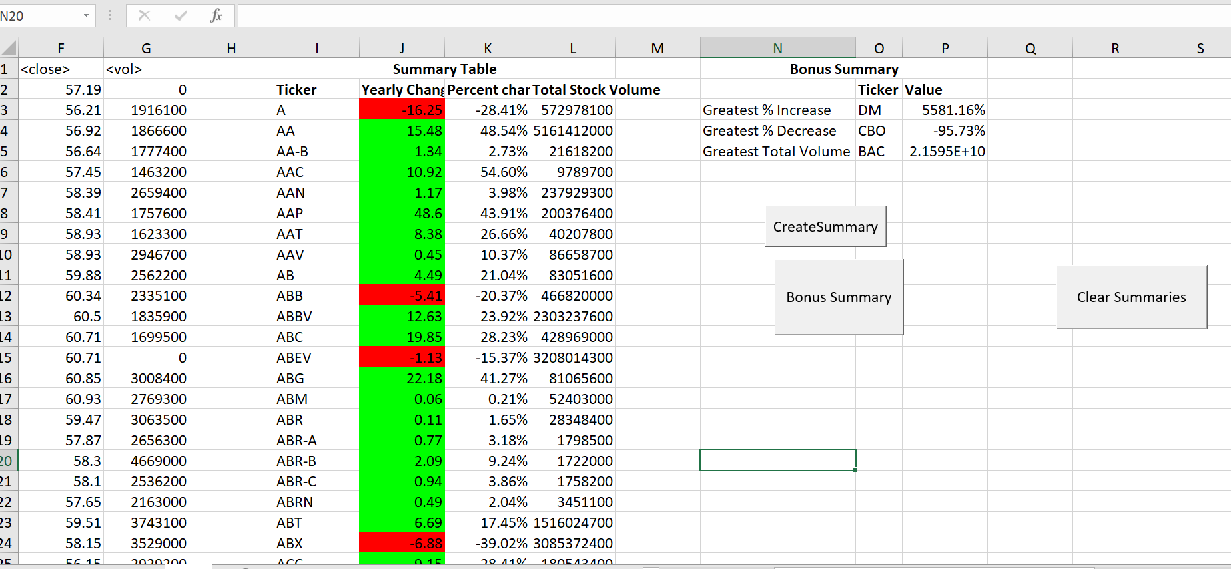

Yearly Summary screen print for 2015:

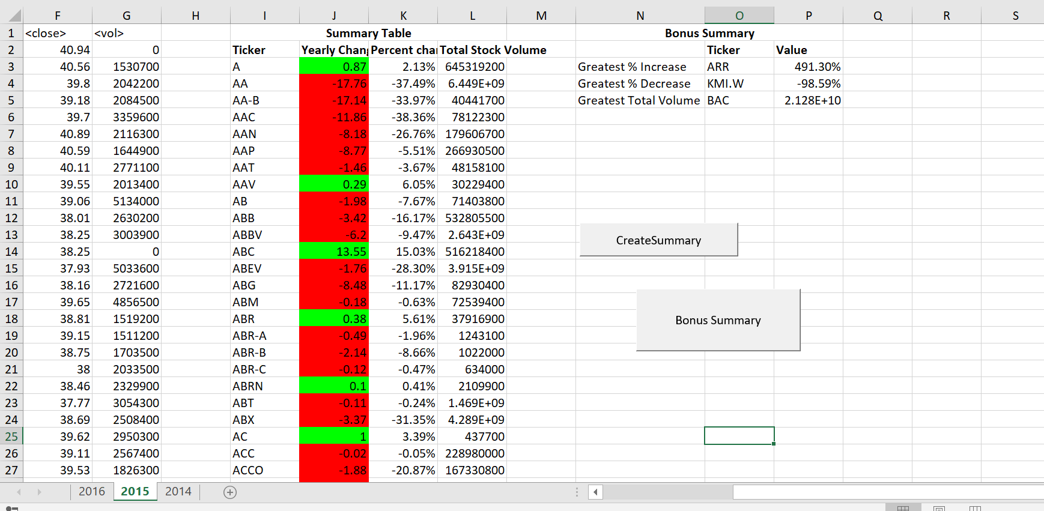

Yearly summary Screen Print for 2016:

